**Medicine Cart**

**Seat No:** 41

*Nikul S. Lakhani*

**OF**

**G H Patel Post Graduate Department of**

**Computer Science and Technology (GDCST),**

**Sardar Patel University, V V Nagar**

**Submitted to**

**SARDAR PATEL UNIVERSITY**

**as a partial fulfillment of the degree of  
Master of Computer Applications (MCA)**

MAY 2017

**G. H. Patel Post-Graduate Department of  
Computer Science & Technology,**

**SARDAR PATEL UNIVERSITY,**

**Near Jain Derasar, Nana Bazar,  
Vallabh Vidhyanagar – 388120,  
Gujarat, India.**

**CERTIFICATE**

This is to certify that **Mr. Nikul S. Lakhani (M14067)**, has worked on the project entitled “Medicine Cart” towards the partial fulfillment of the degree of **Master of Computer Applications** during the final semester at G H Patel Post Graduate Department of Computer Science & Technology, Sardar Patel University, Vallabh Vidhyanagar.

**Date of Submission:**

1st May, 2017

|  |  |
| --- | --- |
| **Seal of the Department** | **Head of The Department** |

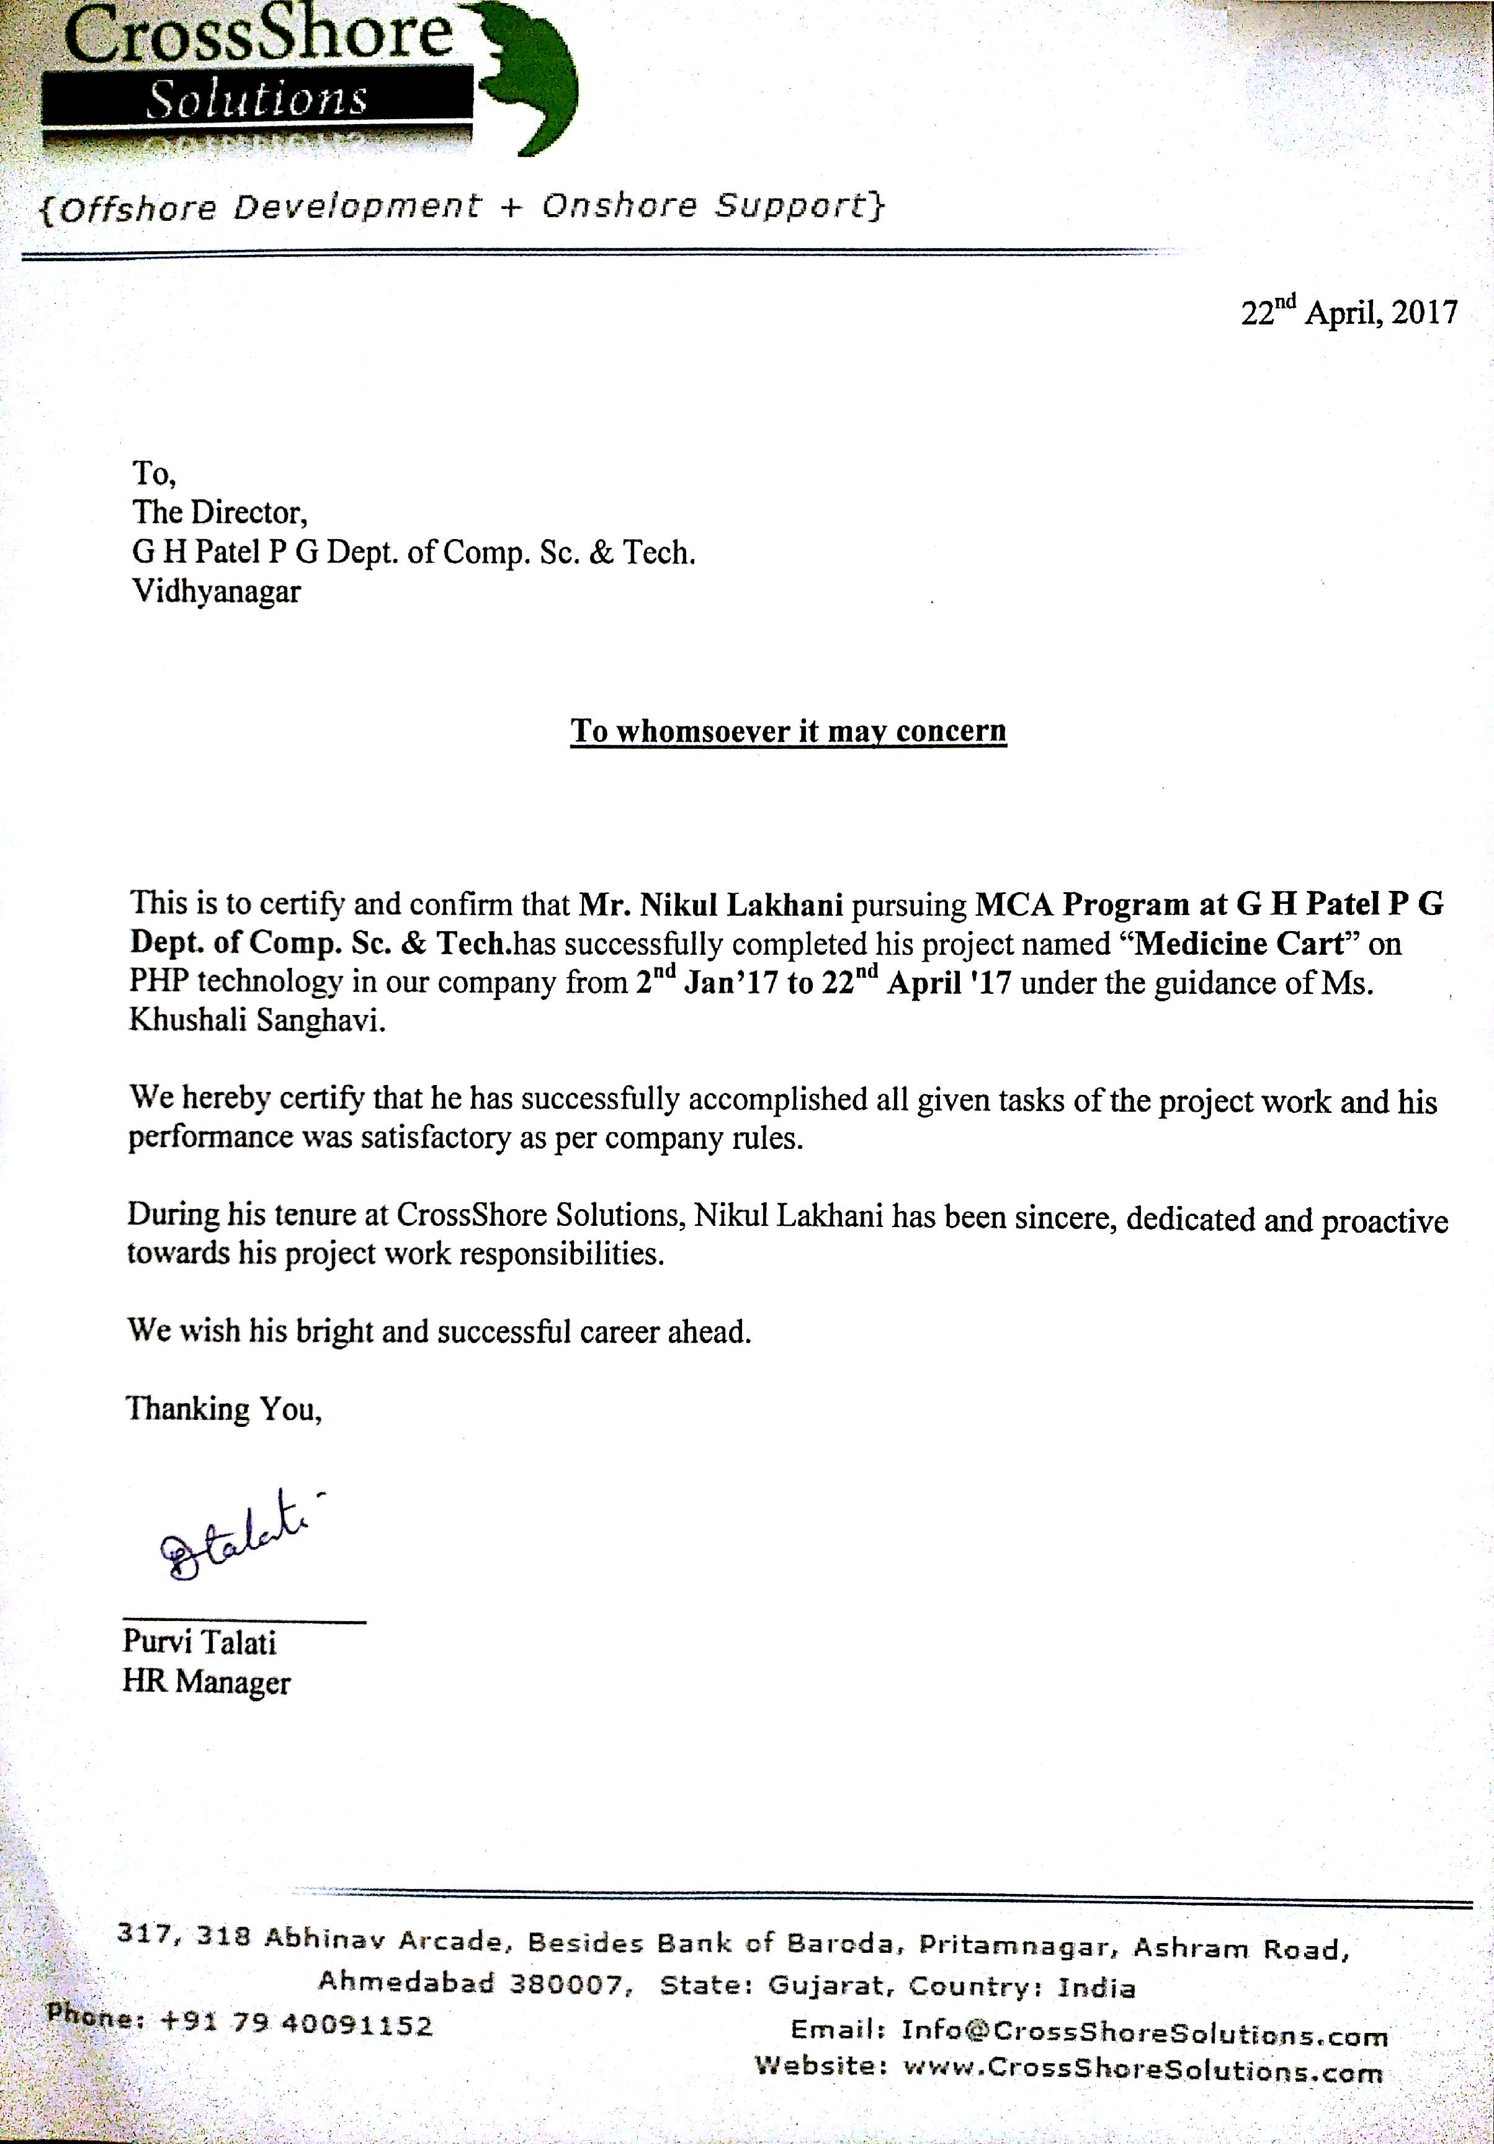

**PREFACE**

“Knowledge and human power are synonymous”, once said the great philosopher Francis Bacon. However, based on experience within today’s global markets, he would probable say, “the ability to capture, communicate, and leverage knowledge to solve problems is human power.” This raises the question how exactly one can best capture, communicate, and leverage knowledge, especially within the world of system engineering.

The answer probably lies in the statement itself- by communicating your ideas and devising ways and means to give shape to your plans into reality. This requires long term planning and shrewd thinking, for it is the long-term investments that will ultimately help you scale great heights.

This semester of “**Master of Computer Applications**” designed keeping the prerogative and the preferences of the industry in mind. This particular semester allows a student to implement what he has learned within the four walls of his classroom. It is here that the mettle of a student is tested to find his suitability for the rigorous tasks assigned to him in the future. A future executive is born on the basis of hard work and dedication he shows during this period of his trainings.

This report that I am submitting intends to highlight my versatility in sustaining the pulls and pressure of the day-to-day professional life and put to perspective the fact that I am capable enough to deliver whenever a challenge is thrown to me. With this report I intend to highlight my thinking about the future trends of the market in general and IT industry in particular.

I believe in right earnest that this report will set precedence not only among our peers but also for those who will follow us in the near future into the IT industry.

I tried my level best for testing this system and represented this report so if misleading information has been enclosed by mistake, please pardon.

**ACKNOWLEDGEMENT**

For the ancestors who paved the path before me upon whose shoulders I stand. This is also dedicated to my family and the many friends who supported me on this journey: Thank you.

I would also like to acknowledge **Ms. Khushali Sanghvi** as the second reader of this document and I am gratefully indebted to her for her guidance, encouragement, unwavering support, collegiality and mentorship throughout the development process of this project. She helped me with the functionalities of the system and solving the technical problems. I really admire her professional attitude.

I would like to extend my thanks to those who offered collegial guidance and support over the years: **Mr. Jignesh Smart**, **Dr. Priti Sajja** and **Dr. Darshan Choksi.**

I would also like to thank all other respected members at **CrossShore Solutions** for helping me a lot in successful completion of my project.

With sincere regards,  
**Mr. Nikul S. Lakhani**

# TABLE OF CONTENTS

Chapter – 1 Introduction 7

1.1 Department Profile 7

1.2 Company Profile 10

Chapter – 2 Project Profile 11

2.1 Project Overview 11

2.2 Project Introduction 12

2.3 Scope 12

2.4 Brief Introduction to Features 12

Chapter – 3 Tools & Technologies 13

3.1 Front-end Tools 13

3.2 Back-end Tools 13

3.3 Documentation Tools 13

3.4 Diagram Tools 13

Chapter – 4 System Analysis 14

4.1 Preliminary Investigation 14

4.2 Feasibility Study 14

4.3 User Characteristics 15

4.4 Constraints 16

4.5 System Requirements 16

Chapter – 5 System Design 17

5.1 Use Case Diagrams 17

5.2 Sequence Diagrams 18

5.3 Activity Diagrams 19

5.4 Class Diagrams 26

Chapter – 6 Database Design 27

6.1 Data Dictionary 27

6.2 Entity Relationship Diagram (ERD) 36

Chapter – 7 Implementation 37

7.1 Coding Standards 37

7.2 Screenshots 39

Chapter – 8 Testing 54

8.1 Testing Plan 54

8.2 Testing Strategy 55

8.3 Testing Methods 55

Chapter – 9 Limitations & Future Enhancements 58

9.1 Limitations 58

9.2 Future Enhancements 58

Chapter – 10 Bibliography 59

# Chapter – 1 Introduction

### 1.1 Department Profile

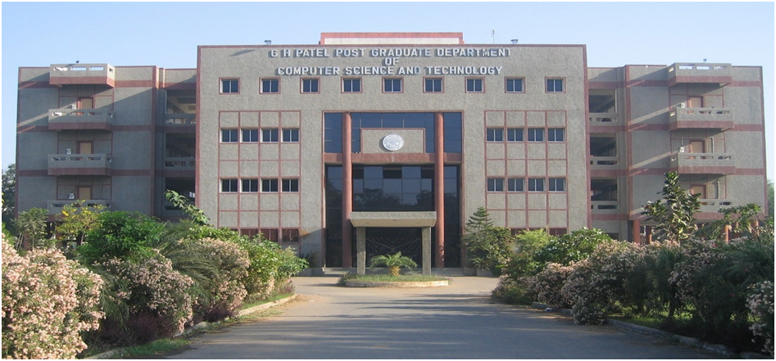

|  |  |
| --- | --- |
| **Department Name:** | G H Patel Post Graduate Department of Computer Science & Technology |
| **University:** | Sardar Patel University |
| **Address:** | Near Jain Derasar, Nana Bazar, Vallabh Vidhyanagar, Anand, Gujarat, India – 388120 |

#### History

The Department of Computer Science was established in the year 1986 as an institution offering postgraduate courses in Computer Science. The computing facility, however, was introduced at the Sardar Patel University somewhere in 1973-74 at the University's computer center with an IBM 1620, a second generation mainframe computer.

The University started one-year Post Graduate Diploma in Computer Applications (PGDCA) course in the academic year 1975, Master of Computer Applications (MCA) in the year 1986, M. Sc. (Computer Science) in 1988, M. Sc. (Bioinformatics) in 2004, M. Phil. (Computer Science) in the year 2008, Ph. D. (Computer Science) in 1990 and Ph. D. (Bioinformatics) in 2011.

Besides these programs, the University also started offering computer related short-term programs from time to time. The computing resources were also used by different postgraduate departments of the University for their Research Work. The institute took lead in establishing links with national and international institutes. The department started a CSI chapter (CSI – the Computer Society of India – is a national professional body having links with various professional bodies in India and abroad) in 1985-86. Various workshops, seminars and symposia have been organized under the CSI banner so far, which have strengthened both the teaching and research activities of the department.

In the year **1988**, Late **Shree Gordhanbhai Hathibhai Patel** donated money to the University for a Separate building of the Post Graduate Department of Computer Science. The department was also recognized by the UGC to provide technical training to personnel at various levels of academia and administration. Several PC based systems had been installed and major research work was carried out in the areas of CAI

The department was recognized and offered 'Refresher Courses in Computer Science' for the Computer Science faculty members in India by the University Grants Commission. In the year 2002, a special **MCA** programme was introduced for providing lateral entry into the second year to computer science graduates. In a short span, the department grew to the extent that a new building was required.

With one more generous donation from Late **Shree Gordhanbhai Hathibhai Patel**, grants from the UGC and he state government and the department's internal sources, a new building of the department with modern infrastructure was constructed. The building was inaugurated on July 22nd, 2002 by HDH Pujya Pramukhswami Maharaj. The name of the department was then changed to **GH Patel Post Graduate Department of Computer Science and Technology** in the year 2002. Subsequently, new powerful servers and several workstations were added to the laboratory and electives for bioinformatics and wireless networks were added to the syllabus. The MSc (Bioinformatics) programme under the UGC Innovative Programme scheme was introduced in the year 2005.

### 1.2 Company Profile

“**CrossShore Solutions**” is an **ASTUTE** **& AGILE** software Development Company offers custom software development services for **MOBILE**, **WEB** and **ENTERPRISE SOLUTIONS** to entrepreneurs, small to large businesses and some of the Fortune 500 companies worldwide.

We provide the offshore as well as onshore development and support to our clients.

{Offshore Development + Onshore Support} = CrossShore Solutions

#### ***Mission***

To be a global leader by offering custom centric software services and products in the eyes of our customers, stakeholders, communities and people

#### ***Our Services***

|  |  |  |  |
| --- | --- | --- | --- |
| **Web Development** | | | **Mobile Development** |
| * PHP Development * ASP.Net Development * RWD (Responsive Web Design) * WordPress Development * Joomla Development * Magento Development | | | * iPhone App Development * iPad App Development * Android App Development * Windows Mobile Development * Mobile Website Development * Hybrid App Development |
| **Address:** | 317, 318 Abhinav Arcade,  Besides Bank of Baroda, Pritamnagar,  Ashram Road, Ahmedabad – 380006  Website: [**http://www.crossshoresolutions.com/**](http://www.crossshoresolutions.com/)  E-mail: info@crossshoresolutions.com  Contact No: +91 79 40091152 | | |

# Chapter – 2 Project Profile

### 2.1 Project Overview

|  |  |
| --- | --- |
| **Project Title** | Medicine Cart |
| **Aim** | The main aim of this system is to provide medicine online by uploading medicine’s **prescription** and its **images** which are recommended by doctors. |
| **Developed At** | CrossShore Solutions |
| **Developed By** | Mr. Nikul S. Lakhani |
| **Project Category** | E-Commerce Website (App & Portal) |
| **Platform Used** | Core PHP |
| **Tools** | Front-end:  * HTML/HTML5 * CSS/CSS3 * Javascript/jQuery * AJAX * NetBeans 7.1  Back-end:  * WAMP Server 2.4 * PHP 5.5.15 * MySQL 4.3.12 * Apache 2.0 |
| **Database** | MySQL 4.3.12 |
| **Duration** | 3.75 Months (1st January, 2017 to 22nd April, 2017) |
| **Team Size** | 1 |

### 2.2 Project Introduction

The main goal of the system is to provide medicines online by uploading **prescriptions** and its **images** which are recommended by doctors.

Users must have to register once in an application in order to place the medicines orders.

Customers are allowed to pay via cash on delivery and they can place multiple orders and notified via SMS or Phone call.

### 2.3 Scope

This system is a web based portal which is managed by store managers as well as system admin. Every store manager can have their own store login so they can view only their sells and orders. Users can place their order from mobile application and their orders are available in store panel of particular store.

### 2.4 Brief Introduction to Features

* Users can order multiple items at a time
* User can also add multiple members from their family
* Cash on delivery is available
* Multiple store manager
* Analytics reports

# Chapter – 3 Tools & Technologies

### 3.1 Front-end Tools

* NetBeans 7.1
* Javascript / jQuery
* AJAX
* HTML / HTML5
* CSS / CSS3

### 3.2 Back-end Tools

* WAMP Server 2.4
* PHP 5.5.15
* MySQL 4.3.12
* Apache 2.0

### 3.3 Documentation Tools

* MS Word 2007
* MS PowerPoint 2007

### 3.4 Diagram Tools

* yEd 3.16.2

# Chapter – 4 System Analysis

### 4.1 Preliminary Investigation

In order to have a perfect preliminary investigation the following activities were undertaken:

* Request Clarification
* Feasibility Study
* Request Approval

### 4.2 Feasibility Study

* Technical Study:

Technical feasibility determines whether the work for the project be done with the present equipment, current procedures, existing software’s technologies and available personnel.

* Operational Feasibility:

The following are some aspects which makes system operationally feasible:

* There is sufficient support of system from intended users of the system.
* Graphical user interface provides easy to run facilities.
* The system will work and there are no major barriers to its implementation within the organization.
* Economic Feasibility:
* Economic feasibility looks at the financial aspects of the project.
* Economic feasibility concern with the returns from the investments in a project.

### 4.3 User Characteristics

There are main three users of the system:

1. Admin

* Login
* Add store managers
* Add users
* Manage all stores
* Manage all users
* Logout

1. Store Managers

* Login
* Add Company
* Add Generic
* Add Category
* Add Products
* Profile Management
* Feedback Listing
* Order Listing
* Store Configuration
* Logout

1. End-users

* Login
* Add Members
* Manage Members
* Place Order
* Cancel Order
* Profile Management
* Logout

### 4.4 Constraints

* User must have to login in order to place the order.
* They can only place orders from mobile application(either Android or iOS)

### 4.5 System Requirements

* Web portal can run in any HTML5 supported browsers.
* Application can run in Android and iOS devices.

# Chapter – 5 System Design

### 5.1 Use Case Diagrams

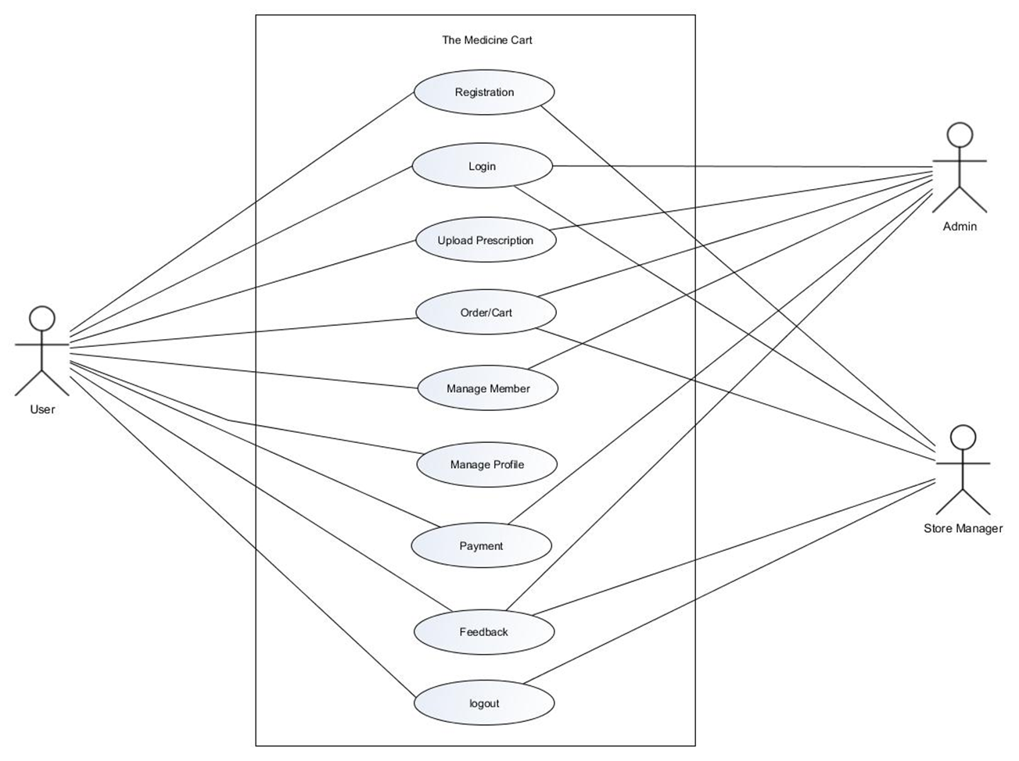

### 5.2 Sequence Diagrams

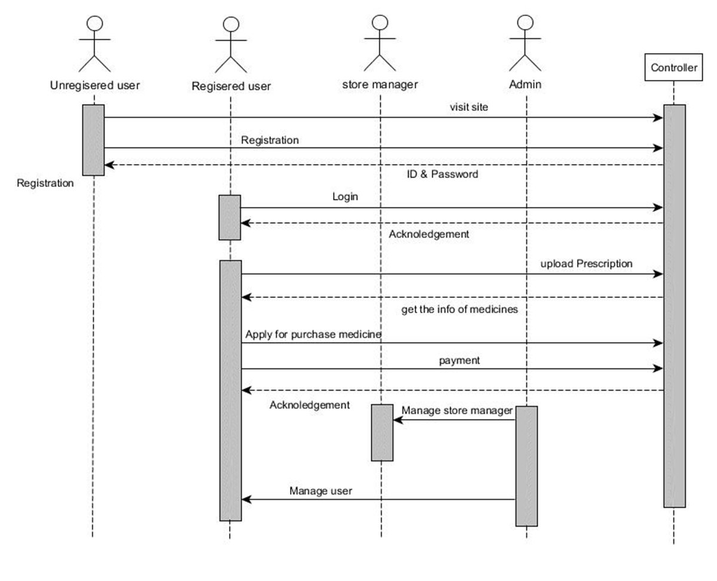

### 5.3 Activity Diagrams

#### Registration Activity:

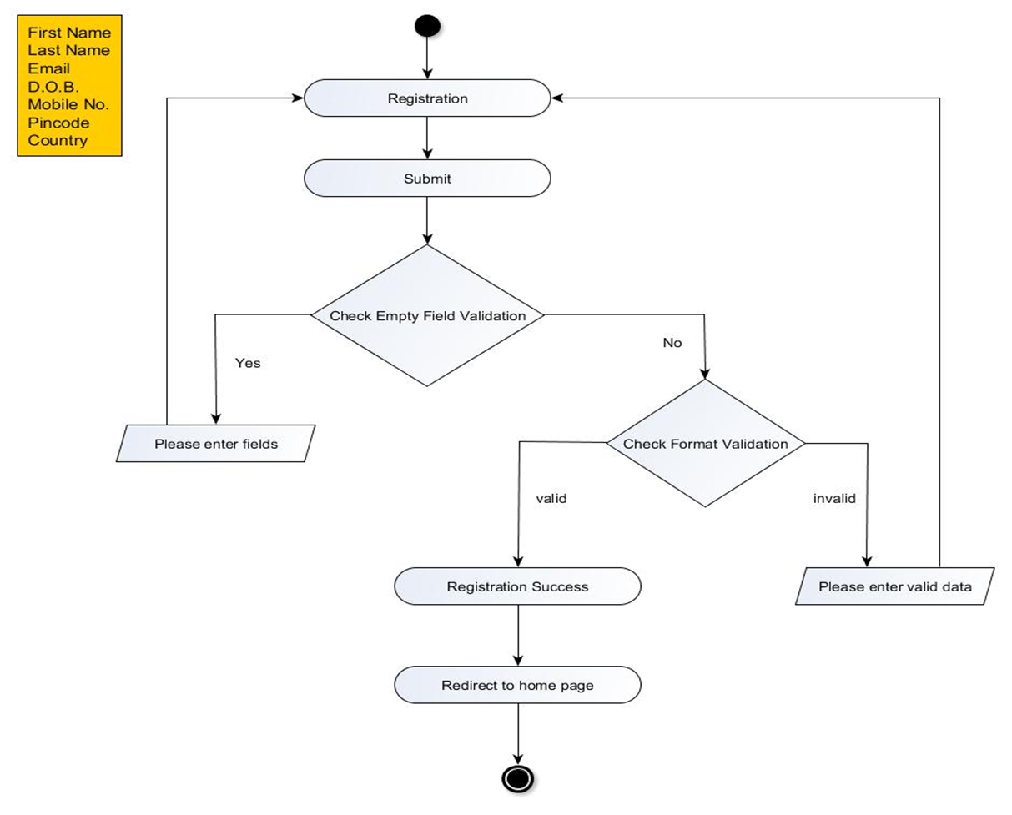

#### Login Activity:

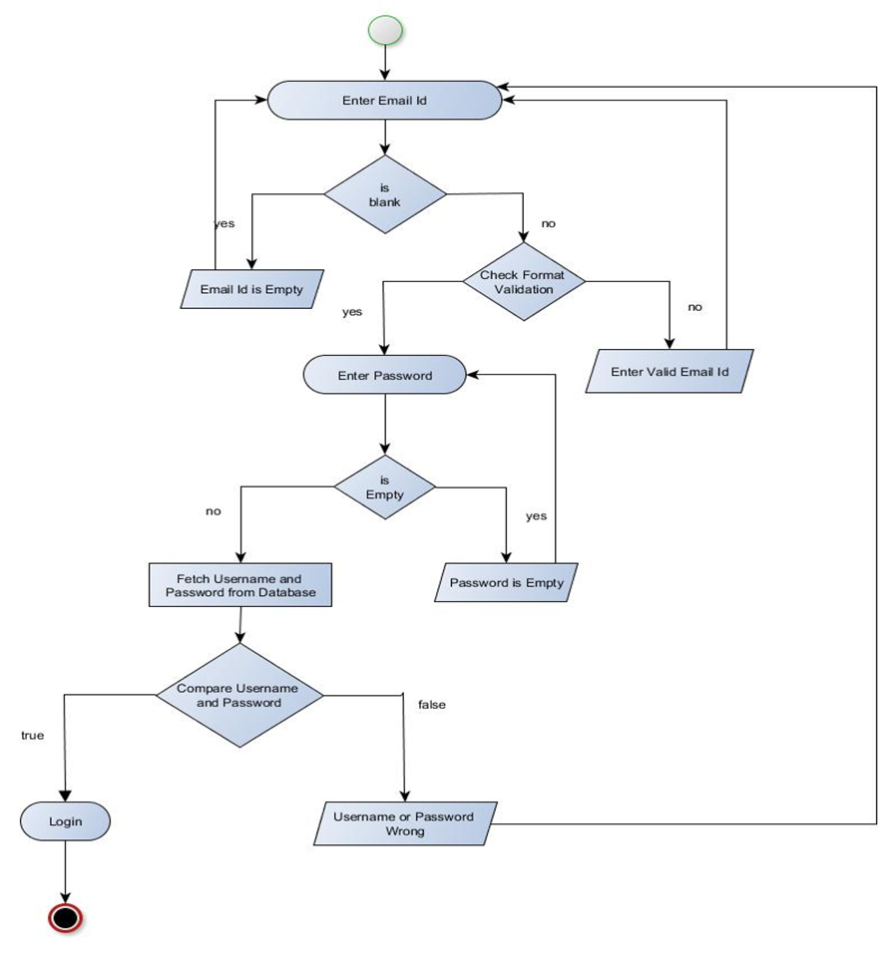

#### Place Order Activity:

#### 

#### Select Delivery Address Activity:

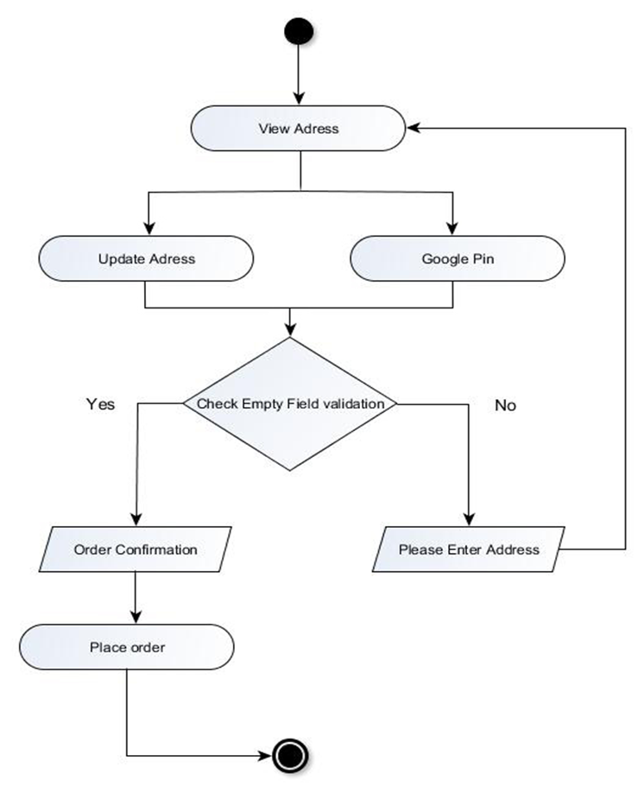

#### Update Profile Activity:

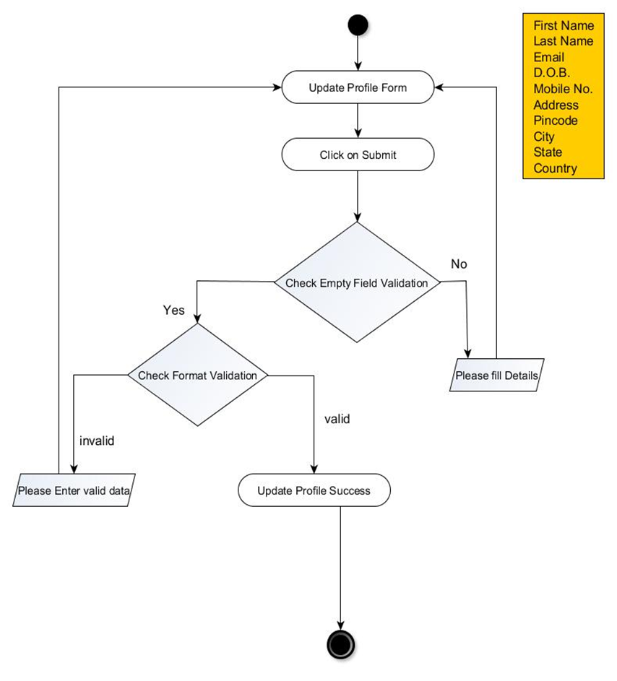

#### Add New Member Activity:

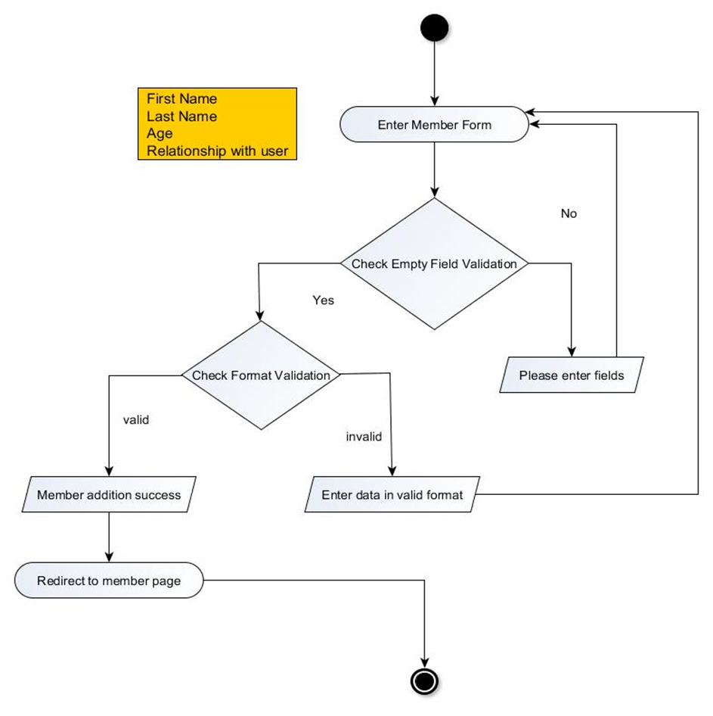

#### Forgot Password Activity:

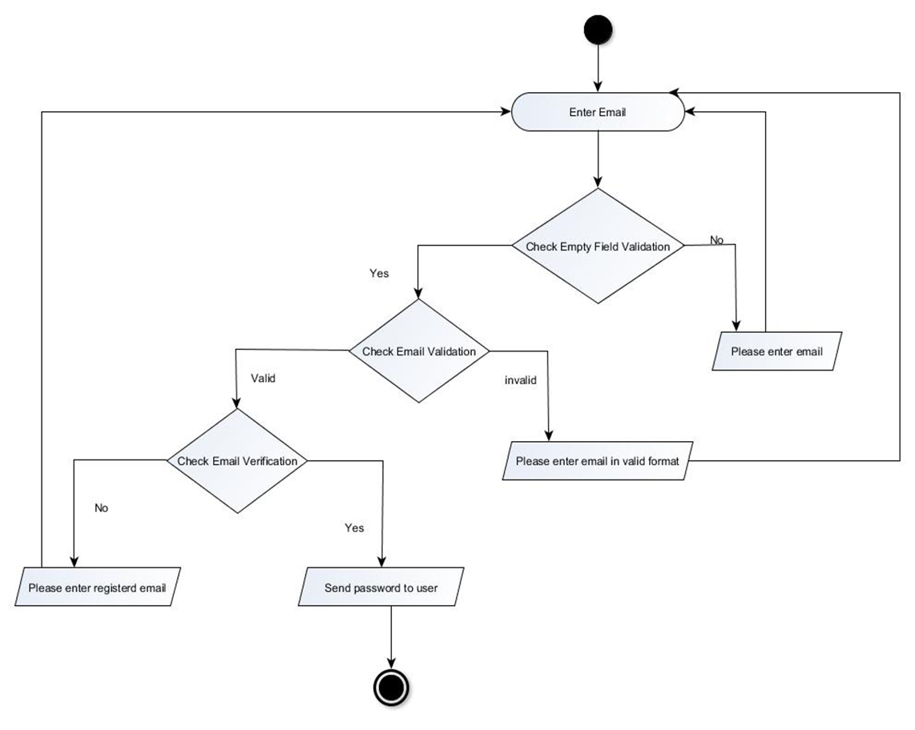

### 5.4 Class Diagrams

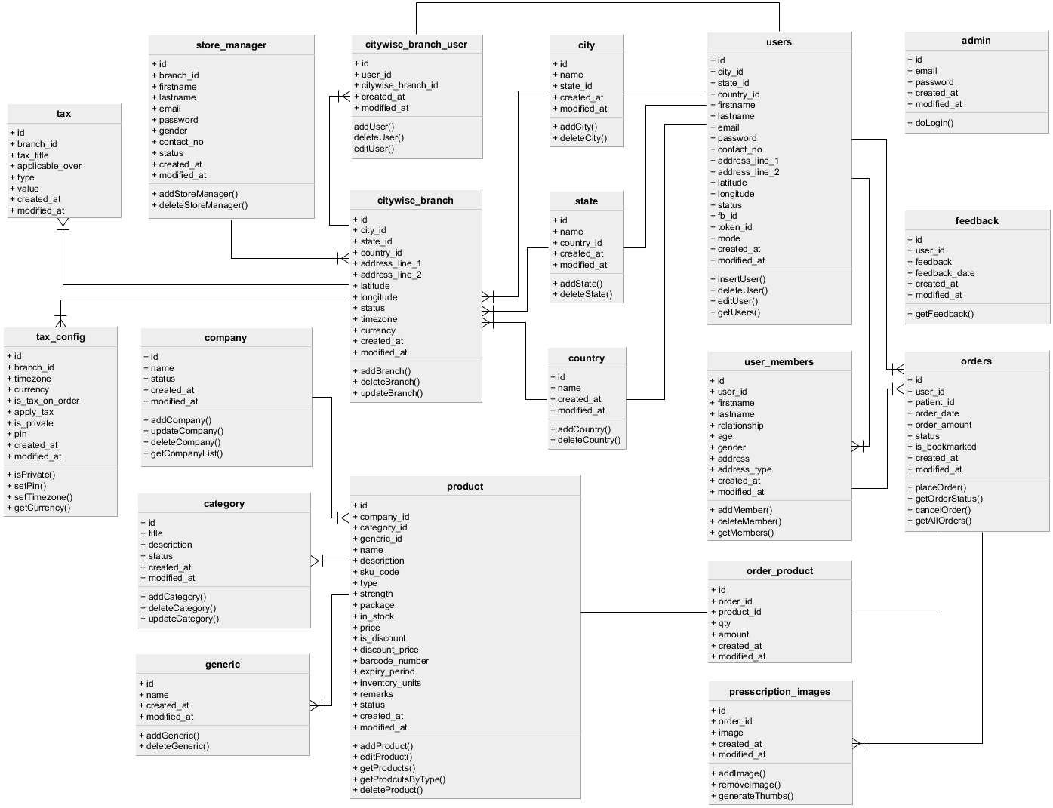

# Chapter – 6 Database Design

### 6.1 Data Dictionary

|  |  |  |  |
| --- | --- | --- | --- |
| **admin** | | | |
| **Field Name** | **Data Type** | **Constraints** | **Extra** |
| id | int(11) | PK |  |
| email | varchar(60) | Not Null |  |
| password | varchar(50) | Not Null |  |
| created_at | timestamp | Not Null |  |
| modified_at | timestamp | Not Null |  |

|  |  |  |  |
| --- | --- | --- | --- |
| **store_manager** | | | |
| **Field Name** | **Data Type** | **Constraints** | **Extra** |
| id | int(11) | PK |  |
| branch_id | int(11) | FK |  |
| firstname | varchar(25) |  |  |
| lastname | varchar(25) |  |  |
| email | varchar(60) | Not Null |  |
| password | varchar(50) | Not Null |  |
| gender | enum |  | 1 – male 2 – female |
| contact_no | varchar(10) |  |  |
| status | enum | Not Null | 1 – active 2 - inactive |
| created_at | timestamp | Not Null |  |
| modified_at | timestamp | Not Null |  |

|  |  |  |  |
| --- | --- | --- | --- |
| **users** | | | |
| **Field Name** | **Data Type** | **Constraints** | **Extra** |
| id | int(11) | PK |  |
| city_id | int(11) | FK |  |
| state_id | int(11) | FK |  |
| country_id | int(11) | FK |  |
| firstname | varchar(25) |  |  |
| lastname | varchar(25) |  |  |
| email | varchar(60) | Not Null |  |
| password | varchar(50) | Not Null |  |
| contact_no | varchar(16) |  |  |
| address_line_1 | varchar(140) |  |  |
| address_line_2 | varchar(140) |  |  |
| latitude | varchar(30) |  |  |
| longitude | varchar(30) |  |  |
| status | enum | Not Null | 1 – active 2 – inactive |
| fb_id | varchar(30) |  |  |
| token_id | varchar(150) |  |  |
| mode | enum | Not Null | 1 – normal 2 – facebook |
| created_at | timestamp | Not Null |  |
| modified_at | timestamp | Not Null |  |

|  |  |  |  |
| --- | --- | --- | --- |
| **user_patient** | | | |
| **Field Name** | **Data Type** | **Constraints** | **Extra** |
| id | int(11) | PK |  |
| user_id | int(11) | FK |  |
| firstname | varchar(25) |  |  |
| lastname | varchar(25) |  |  |
| relationship | varchar(20) |  |  |
| age | int(3) |  |  |
| gender | enum | Not Null | 1 – male 2 – female |
| address | varchar(200) | Not Null |  |
| address_type | enum | Not Null | 1 – home 2 – work 3 – other |
| created_at | timestamp | Not Null |  |
| modified_at | timestamp | Not Null |  |

|  |  |  |  |
| --- | --- | --- | --- |
| **city** | | | |
| **Field Name** | **Data Type** | **Constraints** | **Extra** |
| id | int(11) | PK |  |
| name | varchar(25) | Not Null |  |
| state_id | int(11) | FK |  |
| created_at | timestamp | Not Null |  |
| modified_at | timestamp | Not Null |  |

|  |  |  |  |
| --- | --- | --- | --- |
| **state** | | | |
| **Field Name** | **Data Type** | **Constraints** | **Extra** |
| id | int(11) | PK |  |
| name | varchar(25) | Not Null |  |
| country_id | int(11) | FK |  |
| created_at | timestamp | Not Null |  |
| modified_at | timestamp | Not Null |  |

|  |  |  |  |
| --- | --- | --- | --- |
| **country** | | | |
| **Field Name** | **Data Type** | **Constraints** | **Extra** |
| id | int(11) | PK |  |
| name | varchar(25) | Not Null |  |
| created_at | timestamp | Not Null |  |
| modified_at | timestamp | Not Null |  |

|  |  |  |  |
| --- | --- | --- | --- |
| **citywise_branch** | | | |
| **Field Name** | **Data Type** | **Constraints** | **Extra** |
| id | int(11) | PK |  |
| city_id | int(11) | FK |  |
| state_id | int(11) | FK |  |
| country_id | int(11) | FK |  |
| address_line_1 | varchar(140) |  |  |
| address_line_2 | varchar(140) |  |  |
| latitude | varchar(30) |  |  |
| longitude | varchar(30) |  |  |
| status | enum | Not Null | 1 – active 2 – inactive |
| timezone | varchar(100) |  |  |
| currency | varchar(15) |  |  |
| created_at | timestamp | Not Null |  |
| modified_at | timestamp | Not Null |  |

|  |  |  |  |
| --- | --- | --- | --- |
| **citywise_branch_user** | | | |
| **Field Name** | **Data Type** | **Constraints** | **Extra** |
| id | int(11) | PK |  |
| user_id | int(11) | FK |  |
| citywise_branch_id | int(11) | FK |  |
| created_at | timestamp | Not Null |  |
| modified_at | timestamp | Not Null |  |

|  |  |  |  |
| --- | --- | --- | --- |
| **company** | | | |
| **Field Name** | **Data Type** | **Constraints** | **Extra** |
| id | int(11) | PK |  |
| name | varchar(50) | Not Null |  |
| status | enum | Not Null | 1 – active 2 – inactive |
| created_at | timestamp | Not Null |  |
| modified_at | timestamp | Not Null |  |

|  |  |  |  |
| --- | --- | --- | --- |
| **category** | | | |
| **Field Name** | **Data Type** | **Constraints** | **Extra** |
| id | int(11) | PK |  |
| title | varchar(20) | Not Null |  |
| description | varchar(255) |  |  |
| status | enum | Not Null | 1 – active 2 – inactive |
| created_at | timestamp | Not Null |  |
| modified_at | timestamp | Not Null |  |

|  |  |  |  |
| --- | --- | --- | --- |
| **generic** | | | |
| **Field Name** | **Data Type** | **Constraints** | **Extra** |
| id | int(11) | PK |  |
| name | varchar(100) | Not Null |  |
| created_at | timestamp | Not Null |  |
| modified_at | timestamp | Not Null |  |

|  |  |  |  |
| --- | --- | --- | --- |
| **products** | | | |
| **Field Name** | **Data Type** | **Constraints** | **Extra** |
| id | int(11) | PK |  |
| company_id | int(11) | FK |  |
| category_id | int(11) | FK |  |
| generic_id | int(11) | FK |  |
| name | varchar(100) | Not Null |  |
| description | varchar(255) |  |  |
| sku_code | varchar(20) | Not Null |  |
| type | enum | Not Null | 1 – tablet 2 – syrup 3 – other |
| strength | varchar(30) |  |  |
| package | varchar(50) |  |  |
| in_stock | tinyint(1) | Not Null | 0 – Default |
| price | decimal(10,2) | Not Null | 0 – Default |
| is_discount | tinyint(1) | Not Null | 0 – Default |
| discount_price | decimal(10,2) |  |  |
| barcode_number | varchar(50) | Not Null |  |
| expiry_period | date | Not Null |  |
| inventory_units | varchar(10) |  |  |
| remarks | varchar(200) |  |  |
| status | enum | Not Null | 1 – active 2 – inactive |
| created_at | timestamp | Not Null |  |
| modified_at | timestamp | Not Null |  |

|  |  |  |  |
| --- | --- | --- | --- |
| **orders** | | | |
| **Field Name** | **Data Type** | **Constraints** | **Extra** |
| id | int(11) | PK |  |
| user_id | int(11) | FK |  |
| patient_id | int(11) | FK |  |
| order_date | date | Not Null |  |
| order_amount | decimal(10,2) | Not Null |  |
| status | enum | Not Null | 1 – pending 2 – accepted 3 – onhold 4 – dispatched 5 – delivered 6 – cancelled 7 – rejected |
| is_bookmarked | enum | Not Null | 1 –yes 2 – no |
| created_at | timestamp | Not Null |  |
| modified_at | timestamp | Not Null |  |

|  |  |  |  |
| --- | --- | --- | --- |
| **orders_product** | | | |
| **Field Name** | **Data Type** | **Constraints** | **Extra** |
| id | int(11) | PK |  |
| order_id | int(11) | FK |  |
| product_id | int(11) | FK |  |
| qty | int(11) | Not Null |  |
| amount | decimal(10,2) | Not Null |  |
| created_at | timestamp | Not Null |  |
| modified_at | timestamp | Not Null |  |

|  |  |  |  |
| --- | --- | --- | --- |
| **prescription_images** | | | |
| **Field Name** | **Data Type** | **Constraints** | **Extra** |
| id | int(11) | PK |  |
| order_id | int(11) | FK |  |
| image | varchar(100) | Not Null |  |
| created_at | timestamp | Not Null |  |
| modified_at | timestamp | Not Null |  |

|  |  |  |  |
| --- | --- | --- | --- |
| **tax** | | | |
| **Field Name** | **Data Type** | **Constraints** | **Extra** |
| id | int(11) |  |  |
| branch_id | int(11) |  |  |
| tax_title | varchar(30) |  |  |
| applicable_over | enum |  | 1 – ontax 2 – onorder |
| type | enum |  | 1 – amount 2 – percentage |
| value | decimal(10,2) |  |  |
| created_at | timestamp |  |  |
| modified_at | timestamp |  |  |

|  |  |  |  |
| --- | --- | --- | --- |
| **tax_config** | | | |
| **Field Name** | **Data Type** | **Constraints** | **Extra** |
| id | int(11) | PK |  |
| branch_id | int(11) | FK |  |
| timezone | varchar(50) |  |  |
| currency | varchar(15) |  |  |
| is_tax_on_order | tinyint(1) | Not Null |  |
| apply_tax | enum | Not Null | 1 – perorder 2 – perproduct |
| is_private | tinyint(1) | Not Null |  |
| pin | varchar(6) |  |  |
| created_at | timestamp | Not Null |  |
| modified_at | timestamp | Not Null |  |

|  |  |  |  |
| --- | --- | --- | --- |
| **user_feedback** | | | |
| **Field Name** | **Data Type** | **Constraints** | **Extra** |
| id | int(11) | PK |  |
| user_id | int(11) | FK |  |
| feedback | text |  |  |
| feedback_date | date | Not Null |  |
| created_at | timestamp | Not Null |  |
| modified_at | timestamp | Not Null |  |

### 6.2 Entity Relationship Diagram (ERD)

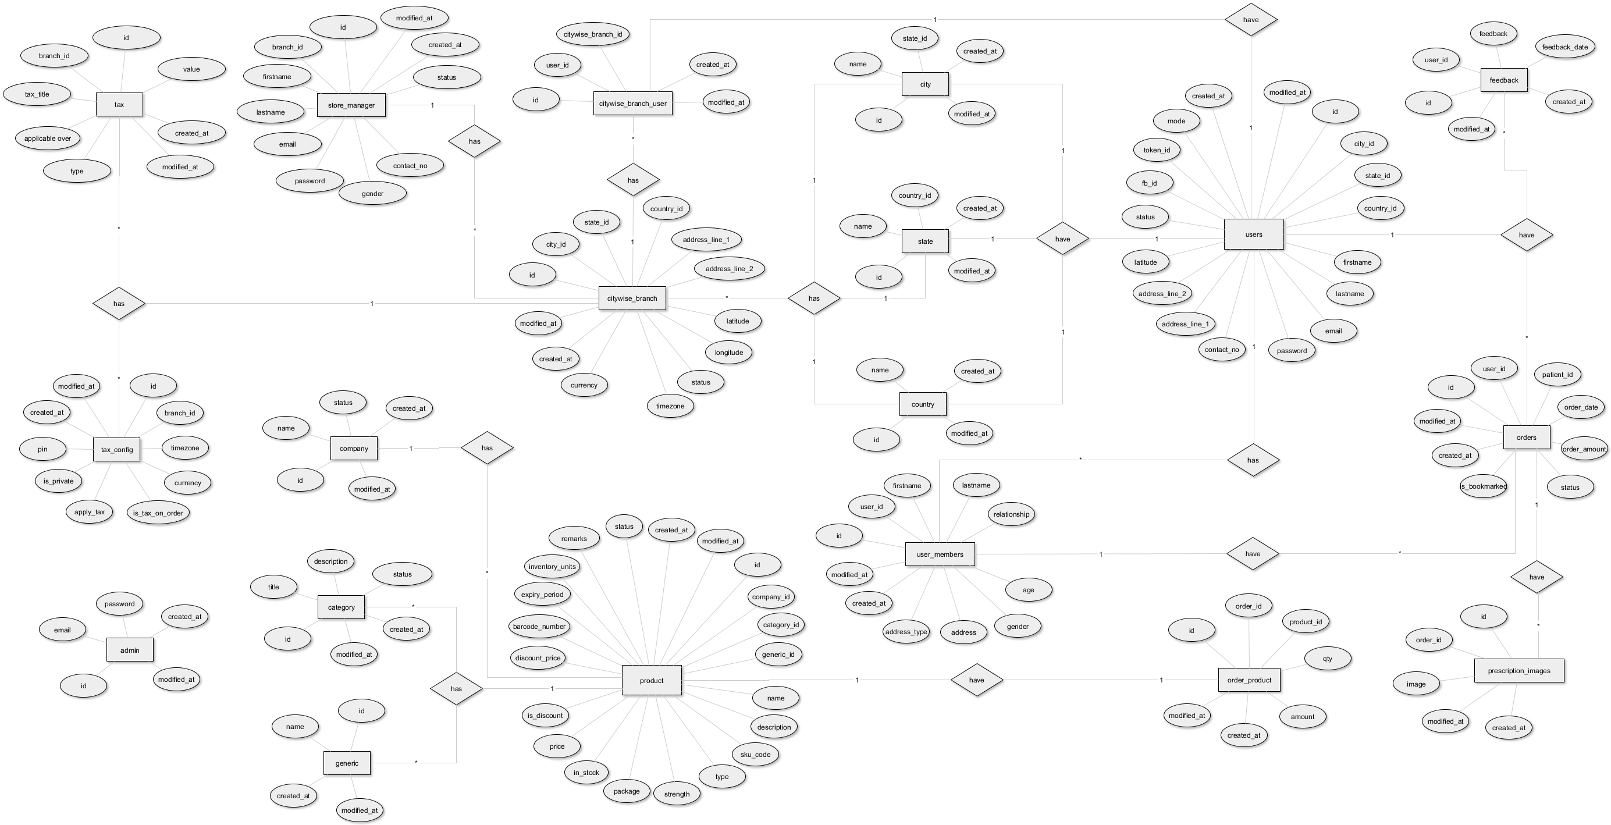

# Chapter – 7 Implementation

### 7.1 Coding Standards

*“The best applications are coded* ***properly****. This sounds like an obvious statement, but by* ***‘properly’****, means that the code not only does its job well, but is also easy to add to, maintain and debug.”*

#### Why to have coding standards:

Coding standards are great – but how to you decide which standards you want to apply, and how they will be defined? When we formulate our ideal coding style, we should think about these points:

* Can you actually read the code? Is it spaced out clearly?
* Do you separate block of code into ‘paragraphs’ so that different sections are easily defined?
* Are you variable naming conventions consistent throughout the code and do they briefly describe that data that they’ll contain?
* Are functions named in accordance with what they do?
* If come back to the code in a few weeks or months, will you be able to work out what’s happening without needing to look at every line?
* How are you commenting your work?

Once we’ve considered those points, we can begin to draft our coding standards. Every developer has their own coding standards, and it will take a while for that developer to change to the new methods.

#### Different Standards:

PHP example code and Pear modules (etc.) generally use the **‘Pear Coding Standards’** which are slightly different from the method we normally use in **C** or **C++** language.

For example, In **C** or **C++**, we normally put the braces for control structures on a new line:

|  |
| --- |
| if (condition)  {  printf(‘Hello World!’);  } |

But in the **Pear** standards, the first brace is on the same line as the ‘if’ (condition):

|  |
| --- |
| if (condition) {  printf(‘Hello World!’);  } |

The standards we choose are all down to personal preference and what we find easiest to code and read.

***Note:*** *In this system we’ve used* ***Pear*** *standards.*

### 7.2 Screenshots

#### Admin & Store Manager Login:

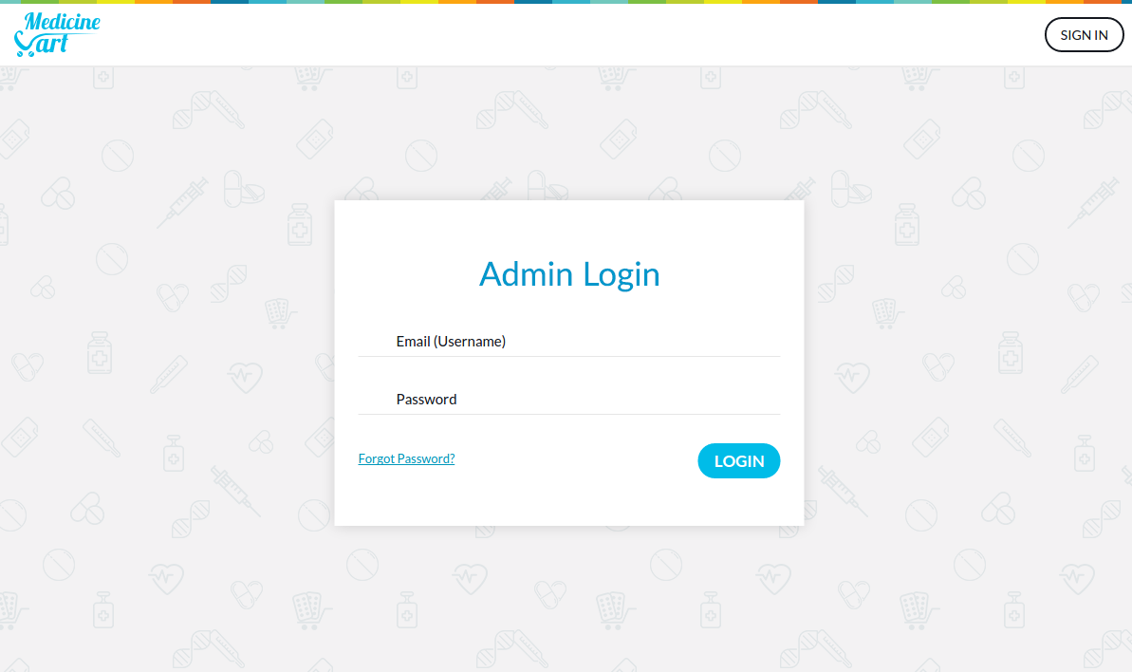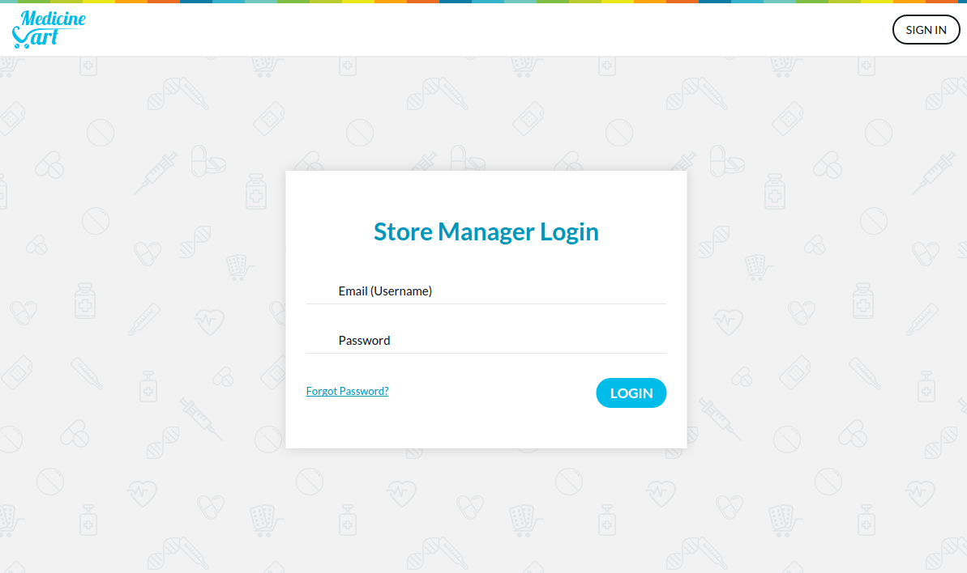

#### Forgot Password:

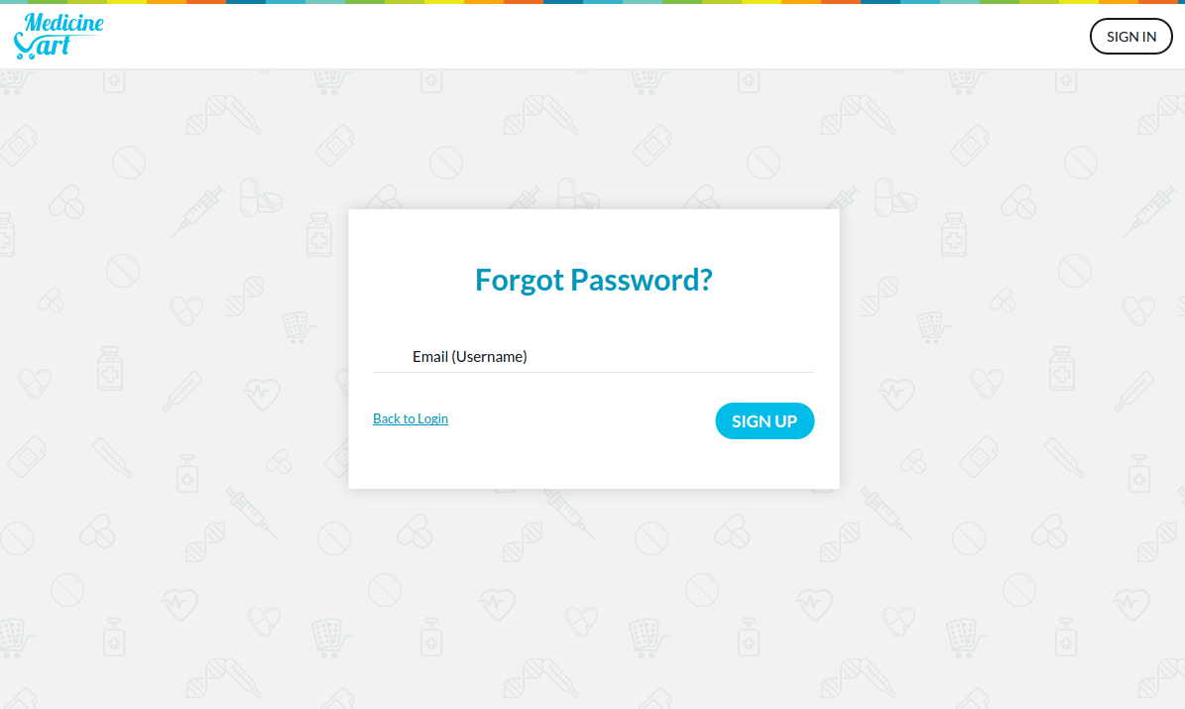

#### Dashboard:

After login, store manager/admin will be redirected to Dashboard page where they can see statistics for their store.

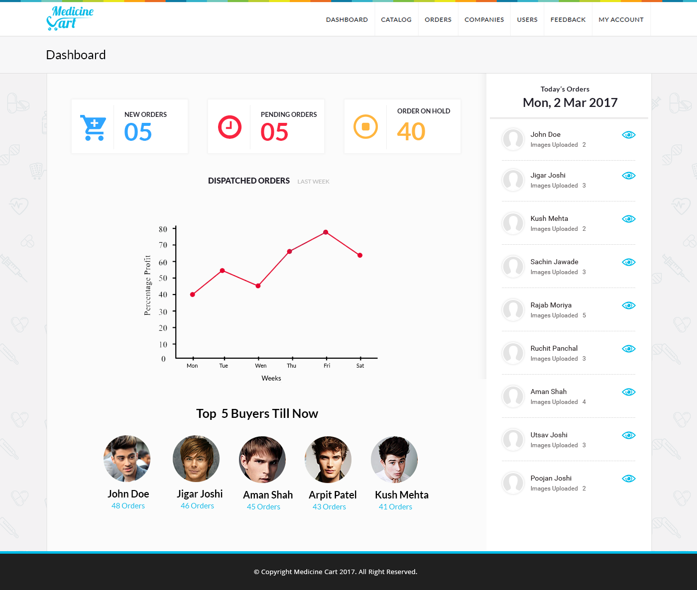

#### Add Product:

Store managers can add new products in their online store; they have to update their stock and products details in store panel for particular product.

There are normally three types of products: **Tablet**, **Syrup** and **Other.**

Store managers can also import multiple products from **CSV** file by clicking on **‘Add Product through CSV’**

Each product has its own **category**, **company** and **generic**.

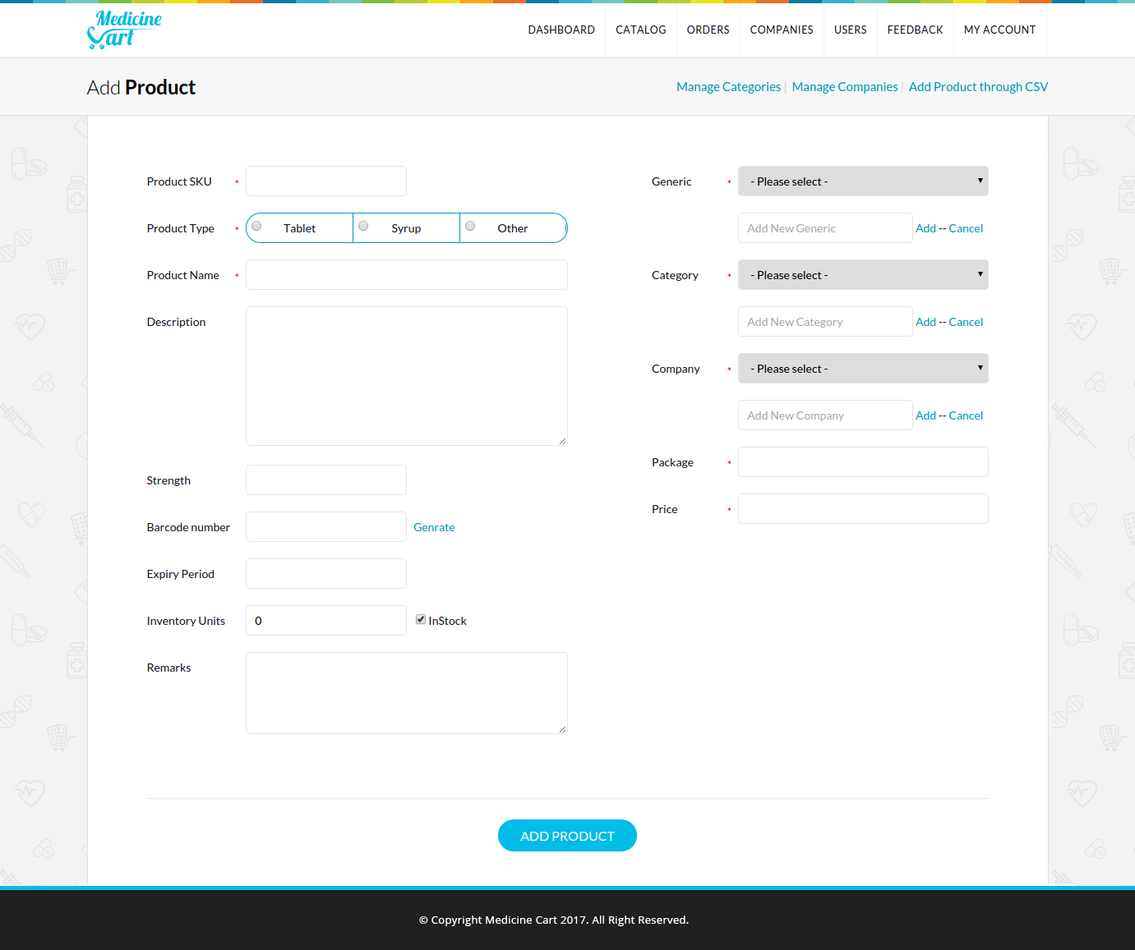

#### Products Listing:

When store manager adds/updates their stock, the change reflects in products listing, where they can see all products either active or inactive in their store.

They can also filter products list via search and other filtering options.

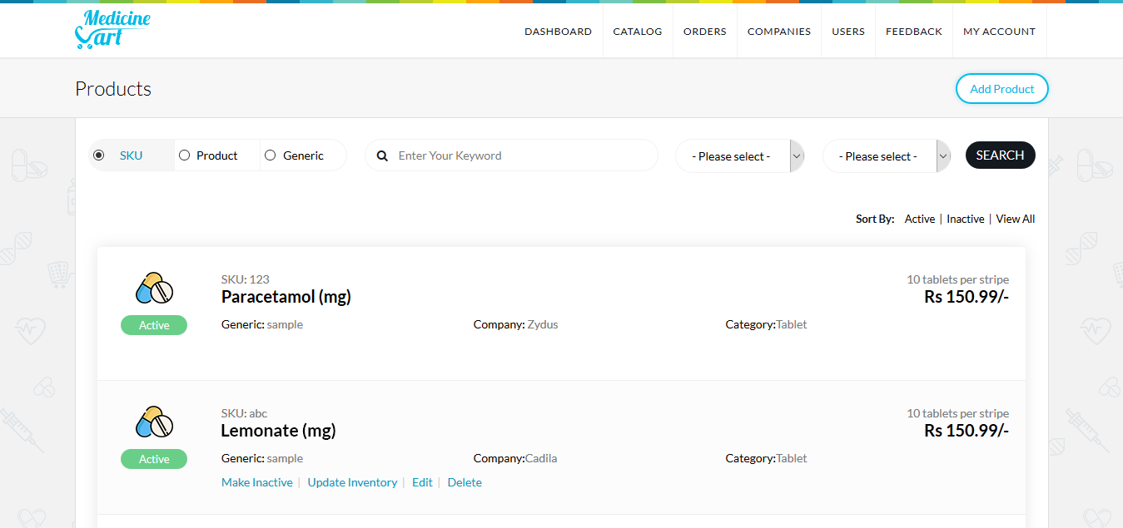

#### Add Category:

Store managers can also add category for their products. For example, Anti-viral drugs, Anti-bacterial medicines etc.

Category title is mandatory but description is optional.

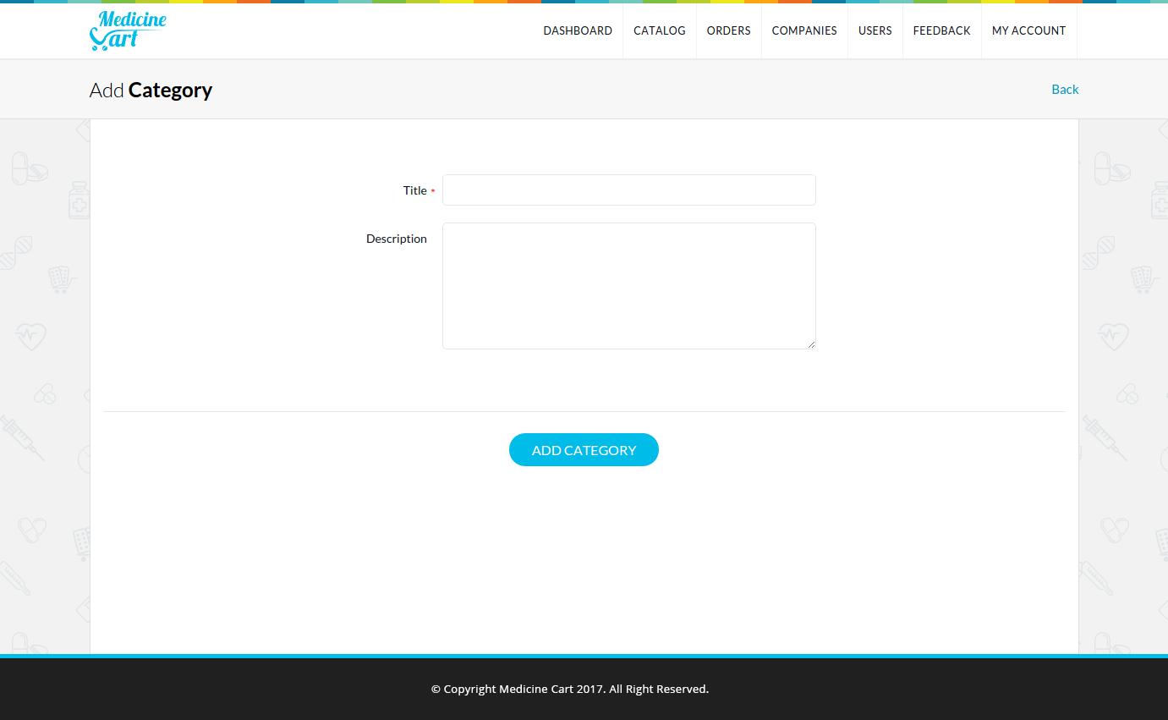

#### Category Listing:

When store manager adds/updates their category list, the change reflects in category listing, where they can see all categories either active or inactive in their store.

They can also filter categories list via search options.

Store manager can change the category status to active or inactive by clicking on **‘Make Inactive’** or **‘Make Active’** link.

They can also browse all products from particular category by clicking on **‘View Medicines’** link.

And every category has its own soft delete link.

***Note:*** *All action links are AJAX callable links.*

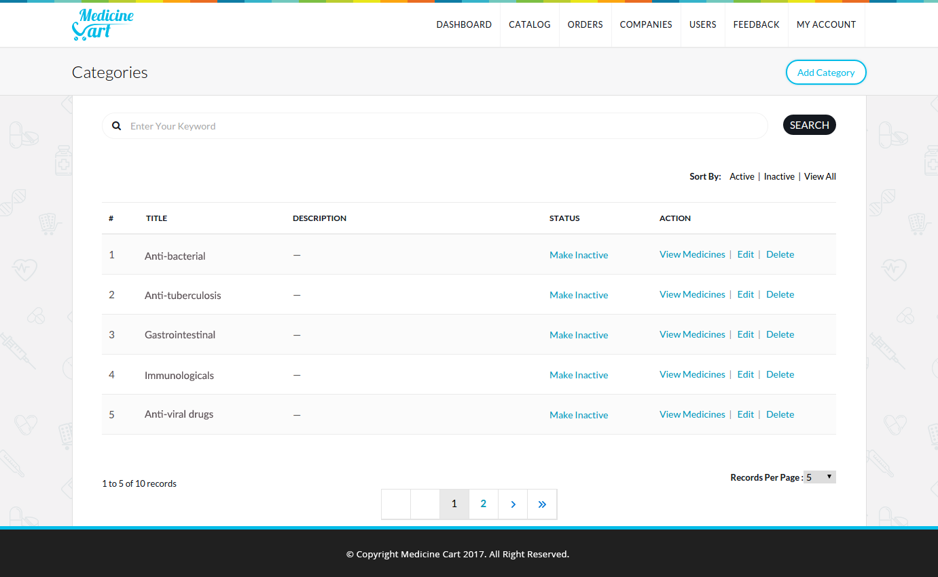

#### Orders Listing:

When end-user places an order from mobile application, store manager can see that order in orders listing page in store panel, where they can view order as well as can manage order’s status. For example, they can reject an order is prescription images are missing or not readable.

Store manager can search and filter orders via search and filtering options.

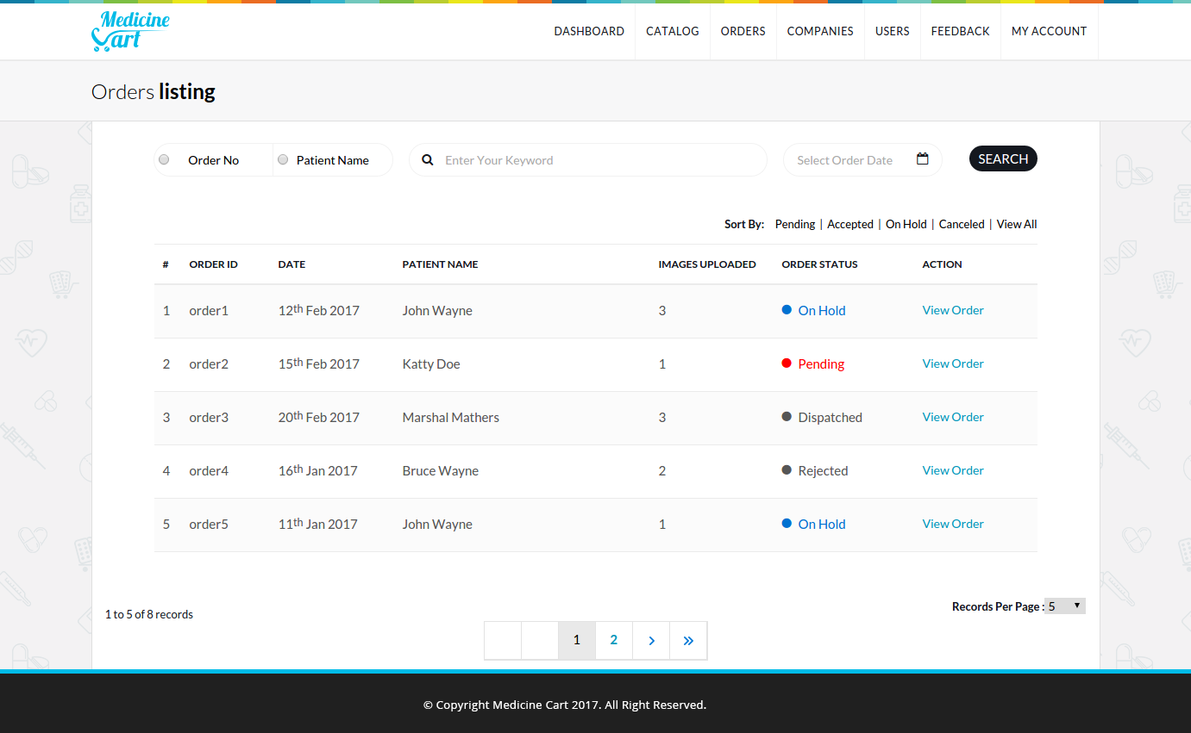

#### Order Listing by Single User:

Store owner can also view list of orders for particular single user. For example, following is a list of orders placed by **‘Nikul Lakhani’**

He has ordered multiple items for their family members, which are shown in the following figure with column name **‘Patient Name’**.

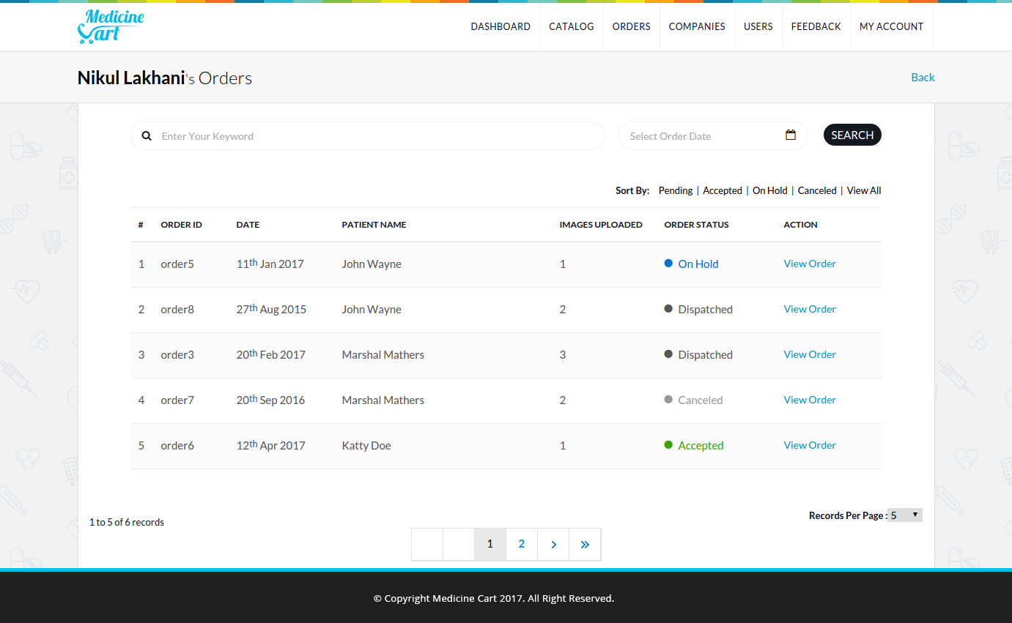

#### Add New Company:

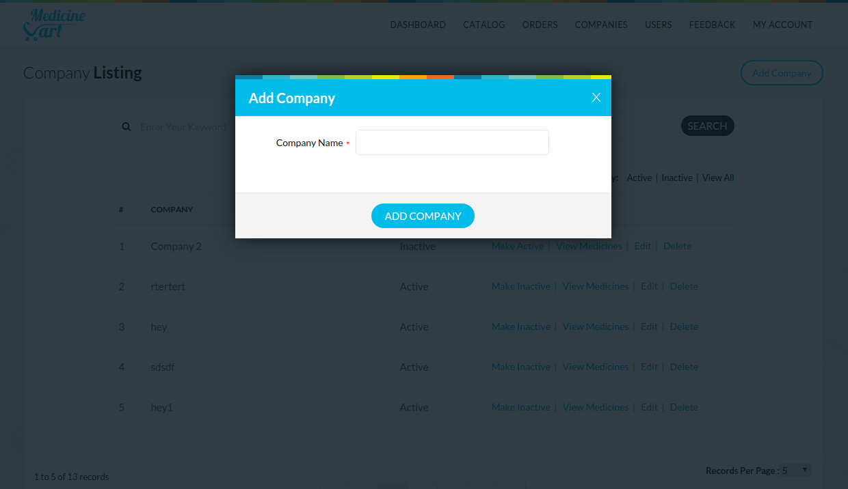

#### Edit Company:

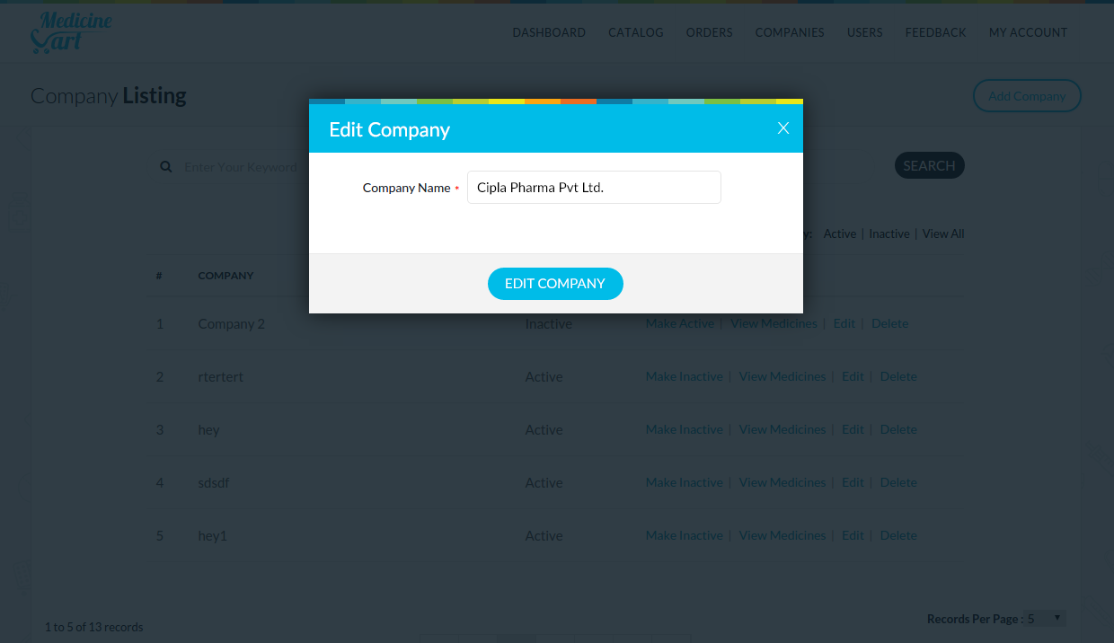

#### Company Listing:

All products in store are from various companies, so store managers can add, edit and list out companies in store panel.

***Notes:*** *All action links are AJAX callable links.*

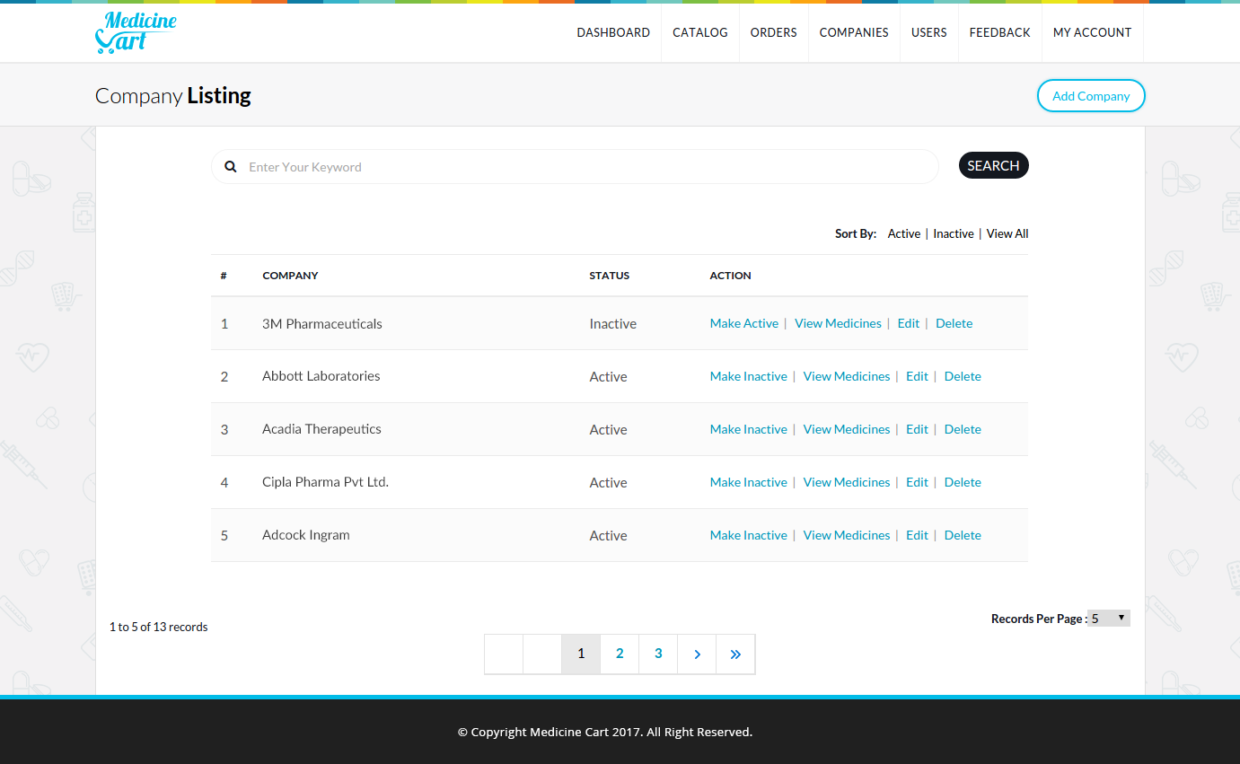

#### User Listing:

This page is only accessible by admin; store managers are not able to view this page.

Admin can navigate to the order listing page for particular user by clicking on **‘View Order’** link.

Admin can also change the status of the user; either **‘active’** or **‘inactive’**, where **‘inactive’** users are not able to login into application.

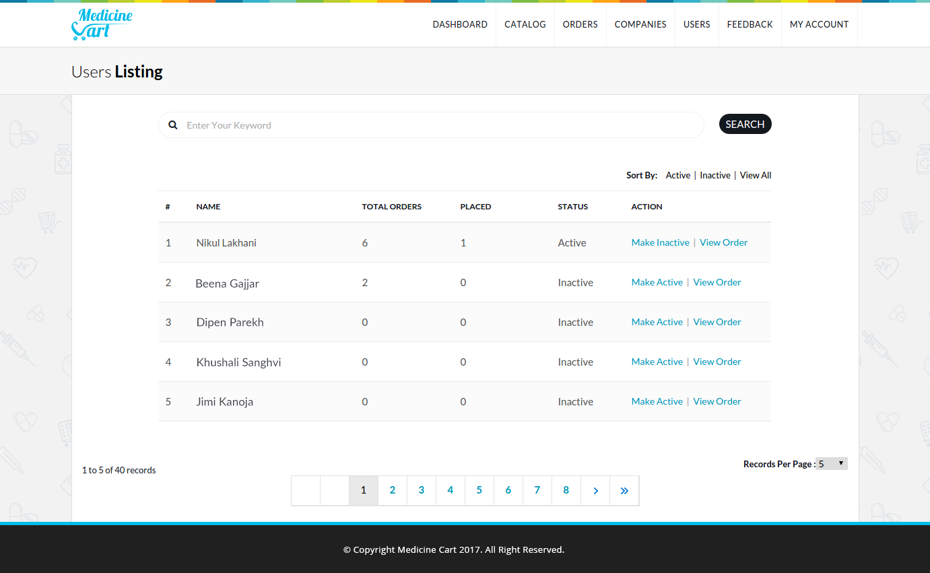

#### Feedback Listing:

When end-user gives feedback from mobile application, it shows in feedback listing page of admin panel.

This page is also not accessible by any store managers.

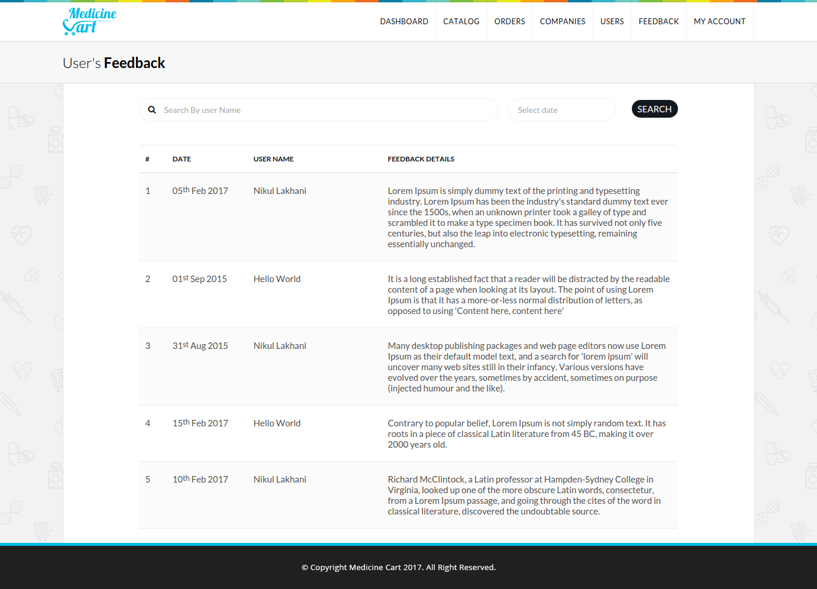

#### Store Configuration Page:

Every store managers have their own configuration page, where they can adjust their all settings related to their online store.

They can adjust time zone based on their time.

Store manager can allow or disallow tax on their products, for that they have a multiple options like applying tax on **‘Per Order’** or **‘Per Product’**.

As well as they can also make their agency as a private, so nobody can see their products in mobile application.

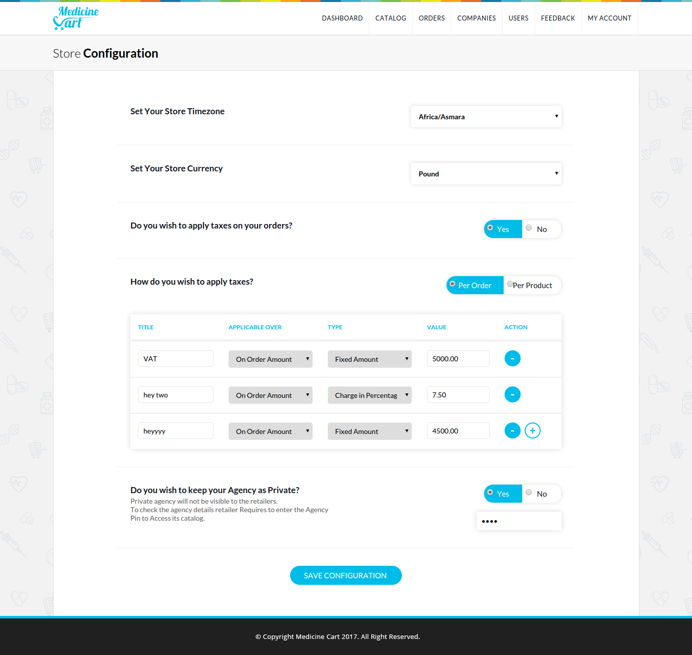

#### Change Password:

Store manager or admin can change their password from this page. End-user can change their password from mobile application; if they have signed up as a **normal user** rather than **‘Login with Facebook’** or **‘Login with Google+’.**

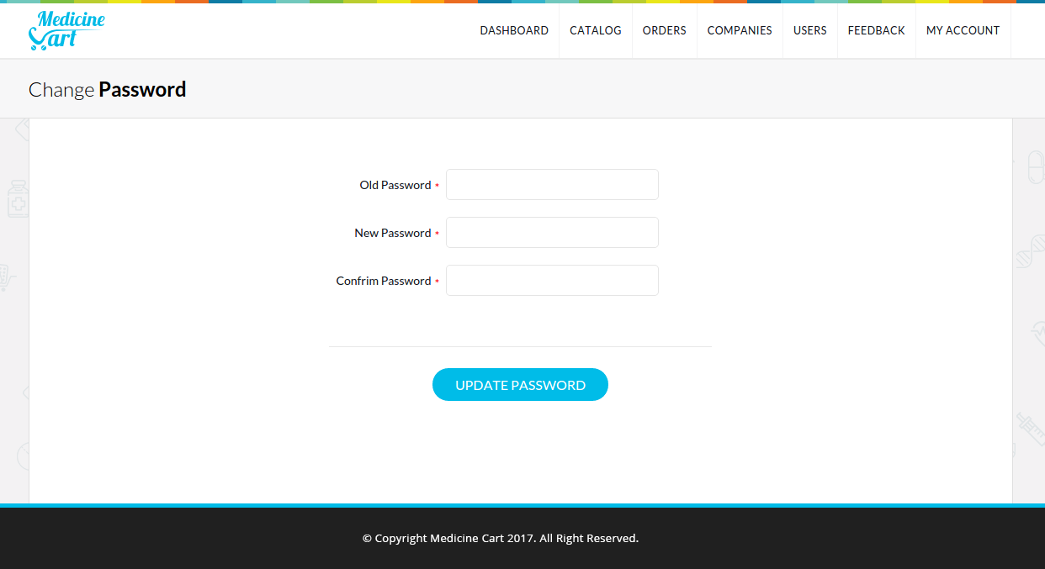

# Chapter – 8 Testing

### 8.1 Testing Plan

#### The Testing Process:

We have tested the software process activates like design, implementation and requirement engineering. As design errors are costlier to repair, once the system has started to operate it is therefore quite obvious to repair them all at the initial stage of the system.

#### Requirement Traceability:

As most interested portion in the system meeting its requirements, therefore testing should be planned so that all requirements are individually tested, we have checked the output of certain combinations of inputs which gives desirable output or not. Strictly going alone, our requirements specifications gave us the path to get desirable result for system users.

#### Tested Items:

Our test items were like, validation of each and every field when user enters the data. The user is not allowed to enter incorrect data and also he is not allowed to leave the text views empty. The mandatory fields which were the necessary fields were tested to contain data and not empty. Places where numeric or alphanumeric characters were required, testing was done to see that no data other than required was entered.

#### Testing Schedule:

We have tested each module Back to Back so that errors and omissions can be found as early as possible. Once the system has been developed fully we tested it on other machines by deploying it on various machines.

#### General Plan for Testing:

The Application is tested using Bottom up testing strategy.

* Testing of each rest service with standard inputs.
* Testing of each individual class files.
* Testing of each individual user interface layout file.
* Module wise testing (all sub modules) while code developed.
* Integration testing of system after integration of individual modules.
* Security testing.
* User level testing.

### 8.2 Testing Strategy

Testing strategy is a general approach to the testing process rather than method of devising particular system or components test. Different testing strategies may be adopted depending on the type of system to be tested and the develop process used. So considering functional oriented nature of this software we adopted mixture of following strategies:

1. A detect found helps in the process of making the software reliable.
2. Even if the defects found are not corrected, testing gives an idea as to how reliable the software is.
3. Over time, the record of defects found reveals the most common kinds of defects is, which can be used for developing appropriate preventive measures such as training, proper design and reviewing.

The testing sub process includes the following activities in a phase dependent manner.

* Create test plans.
* Create test specifications.
* Review test plans and test specifications.
* Conduct test according to the test specifications and log the defects.
* Fix defects, if any.
* When defects are fixed, continue from activity.

### 8.3 Testing Methods

The development process repeats the testing of sub-process a number of times for the following phases:

#### Unit Testing:

Unit testing focuses verification effort on the smallest unit of software design the software component or module. In this type of testing module are tested individually and verified whether accurate output was made available or not.

#### Integrated Testing:

When unit testing was over, all the modules were integrated one by one and tested as a whole. It might be possible that all modules may work individually, but they may not work when put together. Data can be lost across the interface, one module can have an advertise effect on other sub function of another. Global data structure can present problem. So any system has to be tested this way so that the final output is the desired one. Also common functions throughout the system were taken and formed into a class so that they could be accessed from the same place without creating any ambiguity.

#### Validation Testing:

After the integration testing software is completely assembled as a package, interfacing errors have been uncovered and corrected, validation testing begins. Validation testing can be defined as Validation succeeds when the software function in a manner that can be reasonably accepted by the client.

#### Storage Testing:

The database of the system has to be stored on the hard disk. So the storage capacity of the hard disk should be enough to store all data required for the efficient running of the system.

#### System Testing:

Any software is only one element of a larger computer based system. Ultimately software is incorporated with our system elements like hardware, people, information and series of system integration and validation tests are conducted.

System testing is actually a series of different test whose primary purpose is to fully exercise the computer based system. A necessary check to be performed was that of the new system being accepted by the older windows’ application. The data is not being misplaced when both the systems exist.

# Chapter – 9 Limitations & Future Enhancements

### 9.1 Limitations

* Website is not available so user must have to place order from mobile application either android or iOS.
* User can only pay via Cash on Delivery.
* SMS alert is not available.
* User must have to login in order to place new order.

### 9.2 Future Enhancements

* SMS alert will be available so user will receive notifications when their order’s status is changed.
* Messaging facilities between buyers and sellers.
* User can also place order from website, instead of only mobile applications.

# Chapter – 10 Bibliography

* <http://stackoverflow.com/>
* <http://php.net/>
* <https://www.google.co.in/>